**Assignment 1: Function and Array**

Complete the function below to find the max number of the passing array of numbers.  
  
**Reminder:** you *can't* use built-in Math.max() or sort() to complete this assignment.

function max(numbers) {  
   
}  
console.log(max([1, 2, 4, 5])); // expected output: 5  
console.log(max([5, 2, 7, 1, 6])); // expected output: 7

*function* max(*numbers*){

*let* maxnumber = *numbers*[0];

for ( *let* i = 0; i < *numbers*.length; i++){

if(*numbers*[i] > maxnumber){

maxnumber = *numbers*[i];

}

}

return maxnumber;

}

//記得 for loop 中使用;

**Assignment 2: Function and Object**

Complete the function below to calculate the result of the passing object.

function calculate(args) {  
 // your code here  
}  
console.log(calculate({ n1: 2, n2: 3, op: '+' })); // expected output: 5  
console.log(calculate({ n1: 5, n2: 2, op: '-' })); // expected output: 3

console.log(calculate({ n1: 1, n2: 6, op: 'x' })); // expected output: 'Not supported'

*function* calculate(*args*){

*let* value;

if (*args*.op == '+'){

value = *args*.n1 + *args*.n2;

}

else if(*args*.op == '-'){

value = *args*.n1 - *args*.n2;}

else{ value = 'Not supported';}

return value;

}

**Assignment 3: Function, Array, and Object**

Complete the function below to calculate the total price of all products after applying a discount.

function calculate(data) {  
 // your code here  
}  
const discountedPrice = calculate({  
 discount: 0.1,  
 products: [  
 {  
 name: "Product 1",  
 price: 100  
 },

{  
 name: "Product 2",  
 price: 700  
 },

{  
 name: "Product 3",  
 price: 250  
 }  
 ]  
});

console.log(discountedPrice) // show the total price of all products after applying a discount

*function* calculate(*data*) {

*let* sum = 0 ; //初始化 sum

for (*let* i =0; i< *data*.products.length ; i++){

sum += *data*.products[i].price

}

*let* total= sum*(1-*data*.discount);

return total;

}

//return 完 Function 會中止

**Assignment 4: HTML DOM and Event Handling**

Following assignment in week 1, let’s add some effects on it by only pure JavaScript without Bootstrap, jQuery or any other libraries.

**Request 1: Click to Change Text.**

When the user clicks on the "Welcome Message" block, change text to "Have a Good Time!".

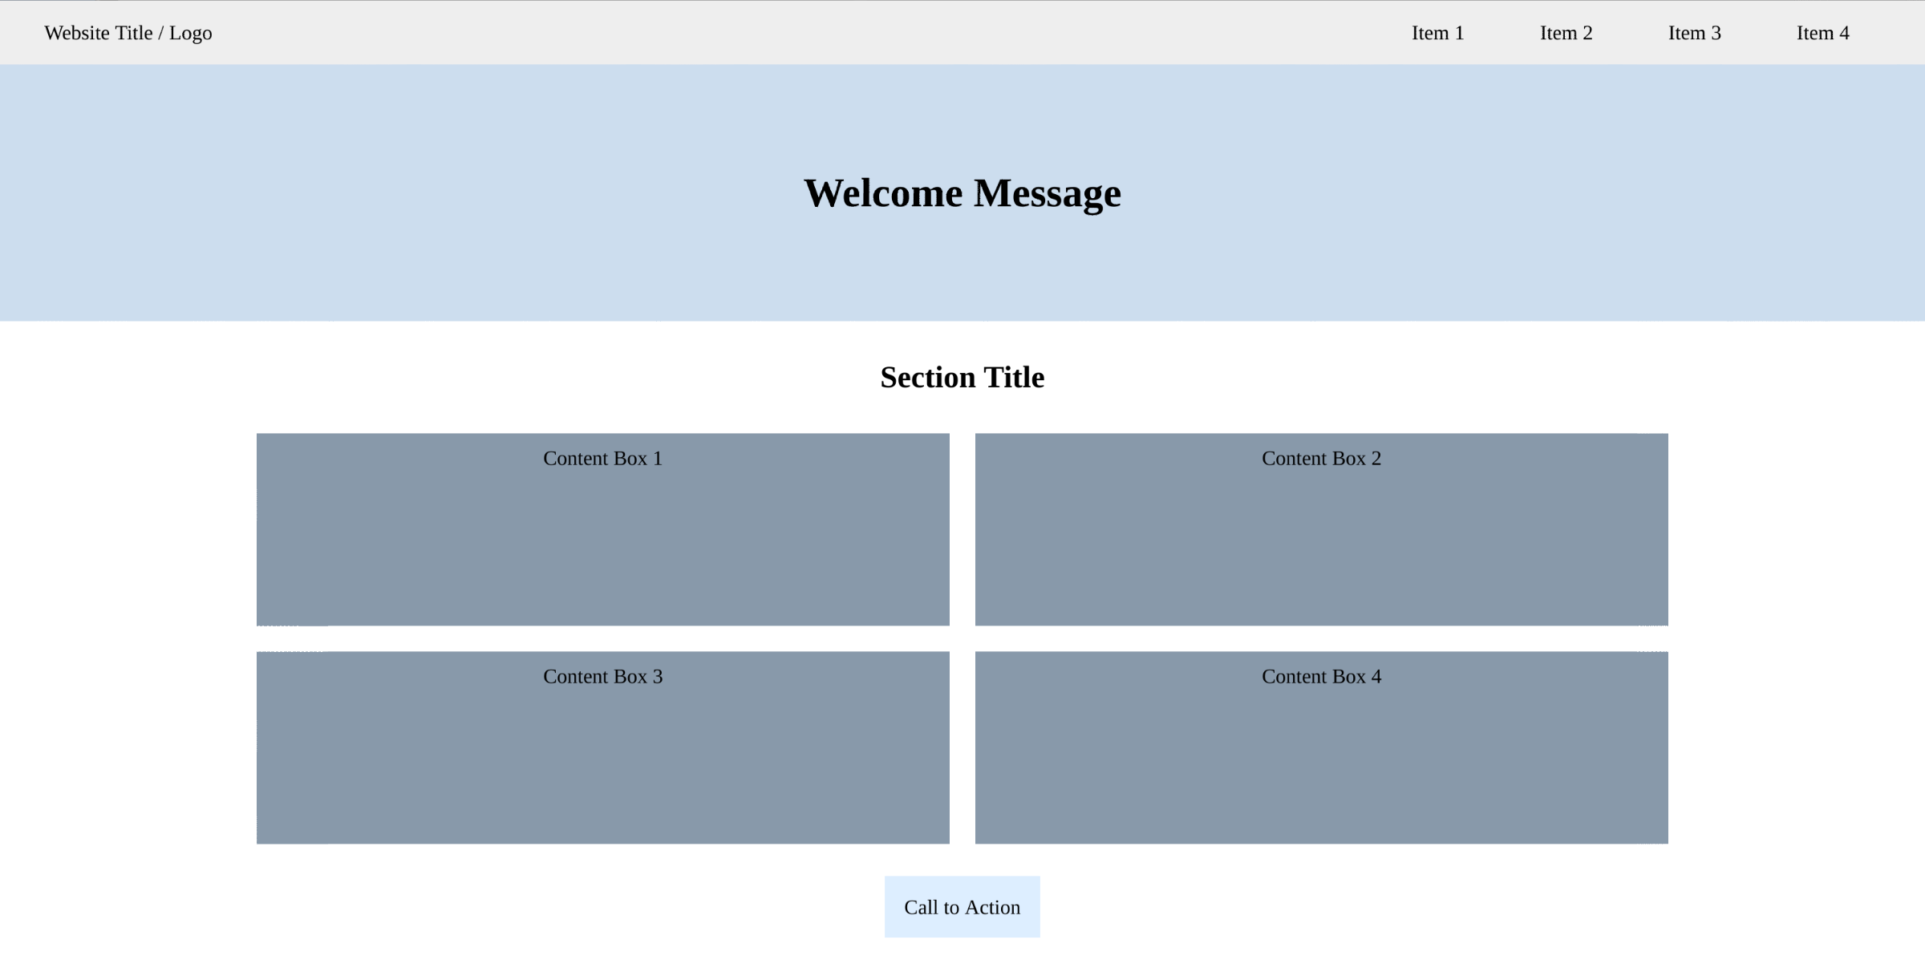

**Request 2: Click to Show/Close Menu.**

When the user clicks the menu at the top-right corner, show the hidden mobile menu. After that, the user can click the close button to hide it.  
  
**Hint:** you may apply css position:fixed to create a floating mobile menu, which may be out of screen at the beginning and totally separated from the original menu.

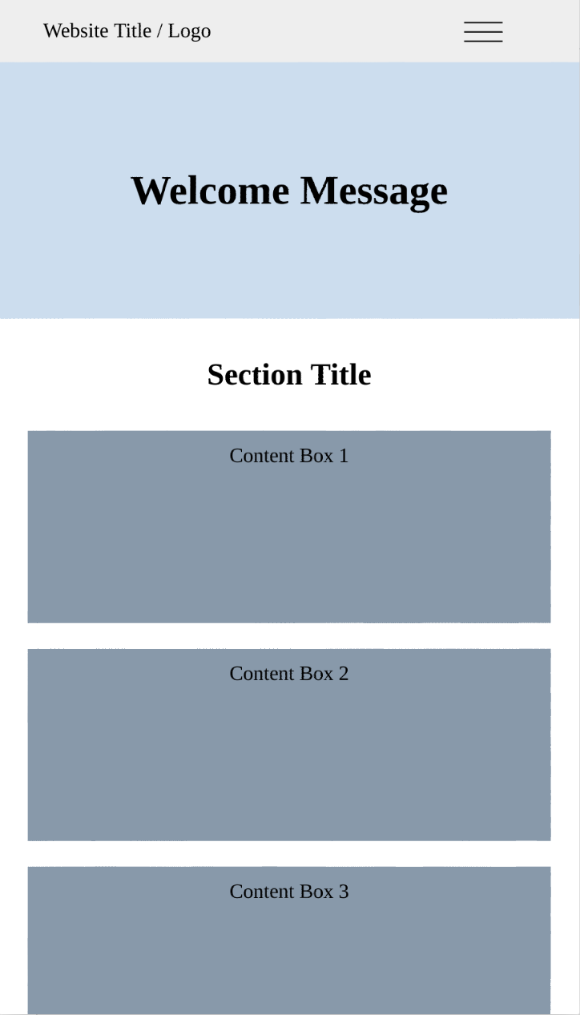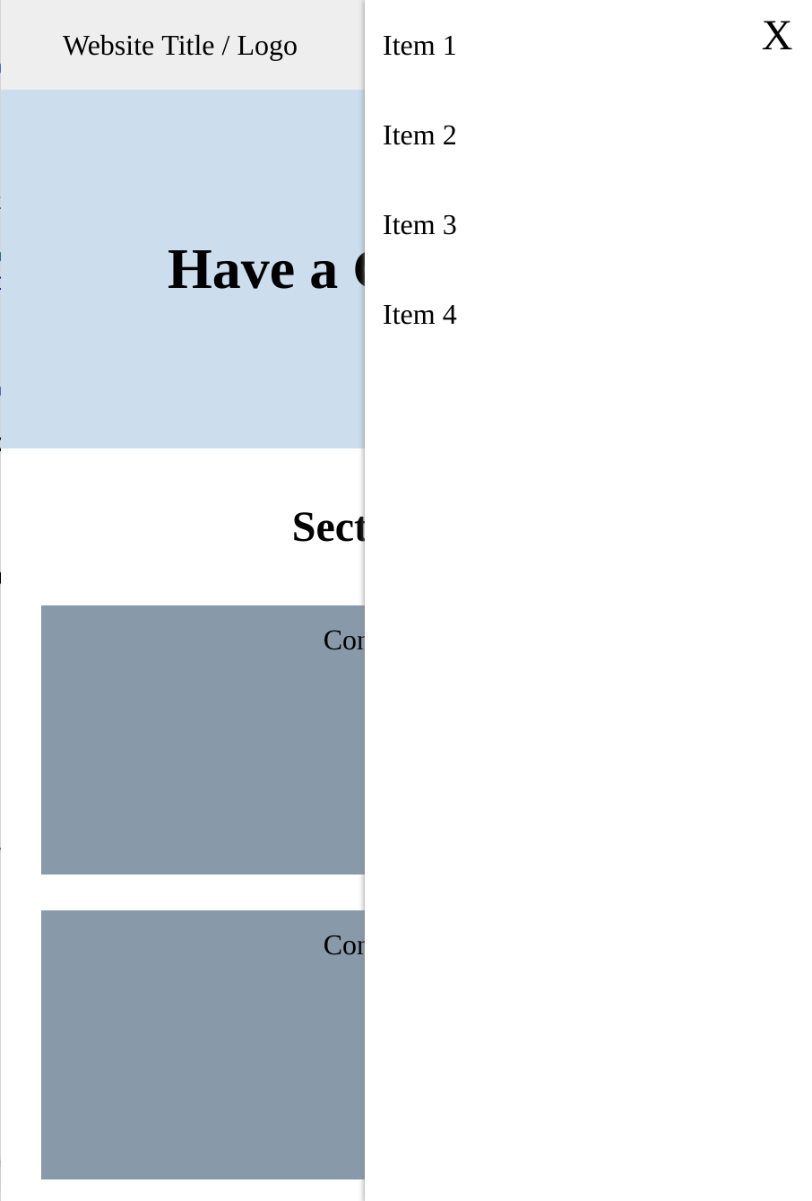

**Request 3: Click to Show More Content Boxes.**

There are some more content boxes waiting to show. When the user clicks the Call-to-Action button, show those hidden content boxes.  
  
**Hint:** all content boxes are already there, they are just set to display:none at the beginning.

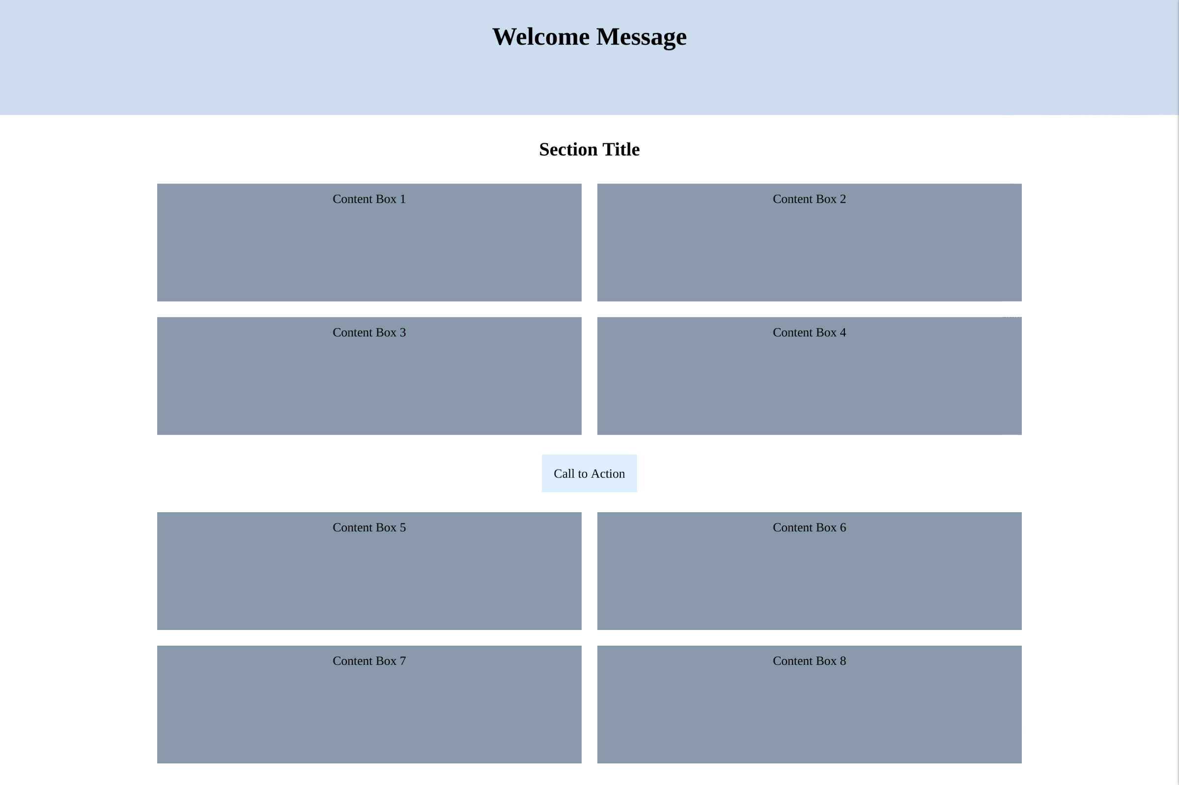

**Assignment 5: Algorithm (Advanced Optional)**

Given an array of integers, return indices of the two numbers such that they add up to a specific target. You may assume that each input would have exactly one solution, and you may not use the same element twice.

function twoSum(nums, target) {  
 // your code here  
}

/*  
 For example:  
 twoSum([2, 7, 11, 15], 9);  
 Should returns:

[0, 1]

Because:

nums[0] + nums[1] is 9

*/